MS_TE_GroupInforIpadApp SimpleReport

YUKUI YE

[yye@syr.edu](mailto:yye@syr.edu)

315-751-0156

Part 1: Master/Detail View Controller -> Enbeded UIWebViewController

Create a new plist (Key: a list of group member’s name.; Value: ProfileWebLink)

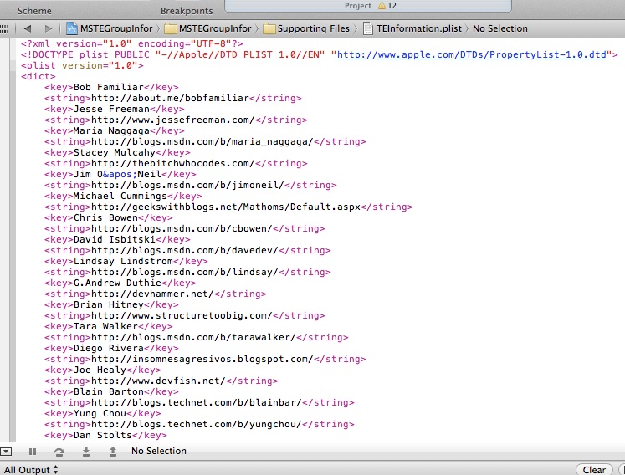

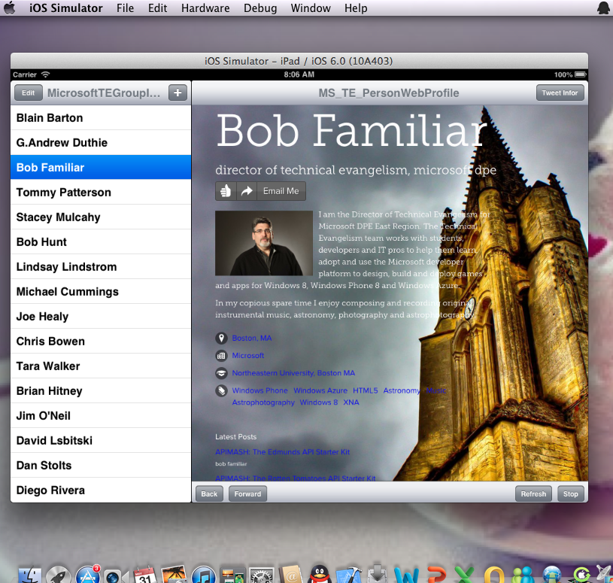

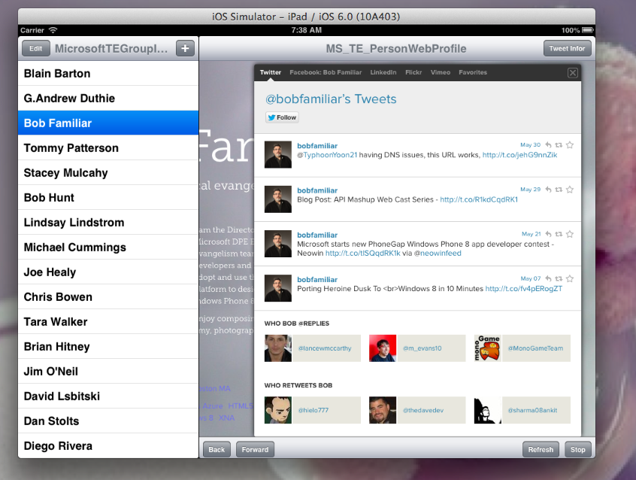

Part2: Twitter Framework

New above ios5, there is a built-in Twitter framework, managing Twitter accounts and permissions to use the twitter account that the user registered in setting. Provide a simple view controller for composing and posting a tweet. Serves as a thin wrapper around twitter’s own RESTful web API.

Sending Tweets To Twitter

Built in Tweet composer: TWTWeetComposeViewController

handles interaction with system Twitter accounts

Can add images and URLs

Check whether you have permissions :

[TWTweetComposeViewController canSendTwee]

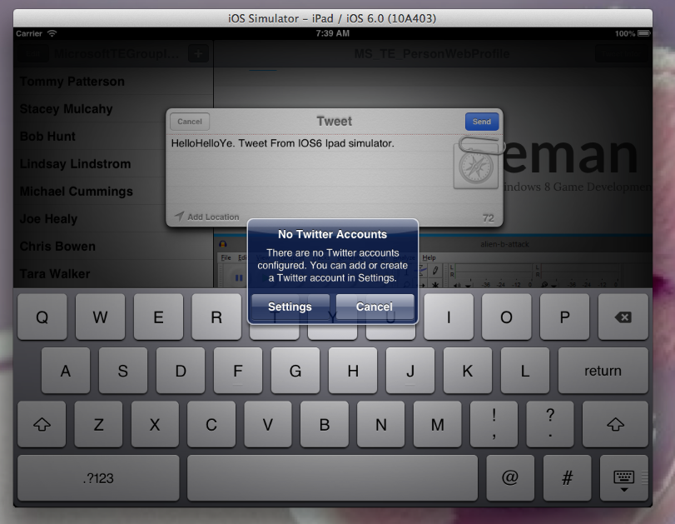

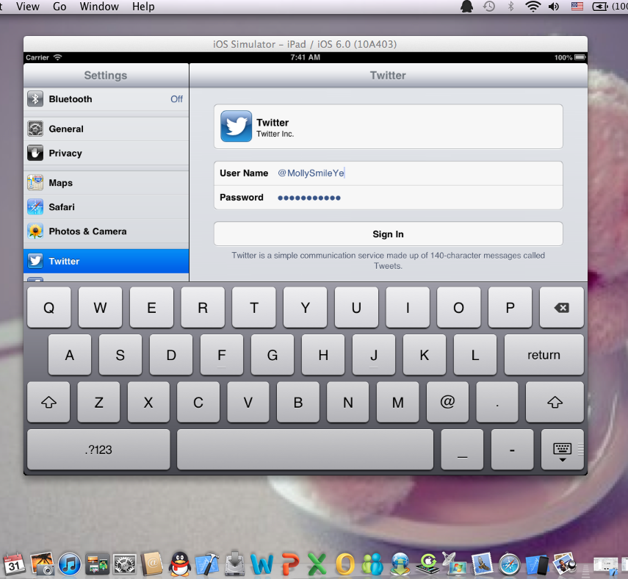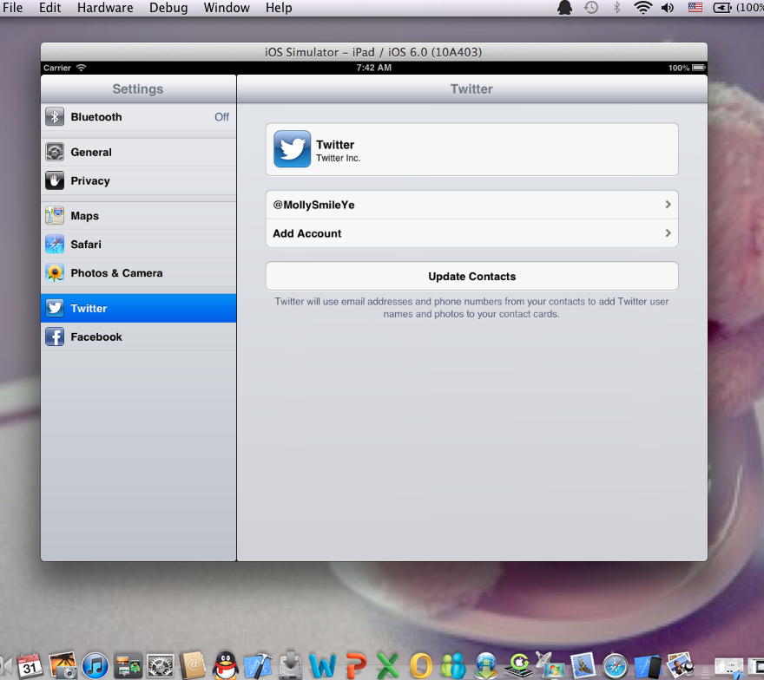

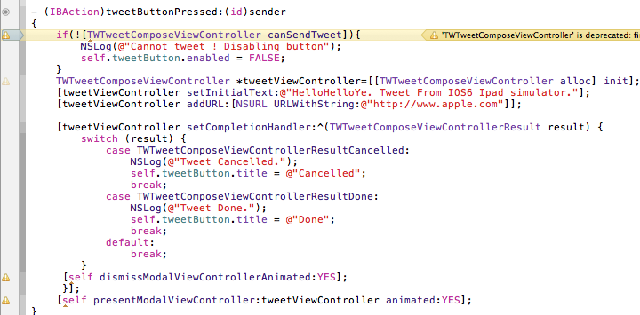

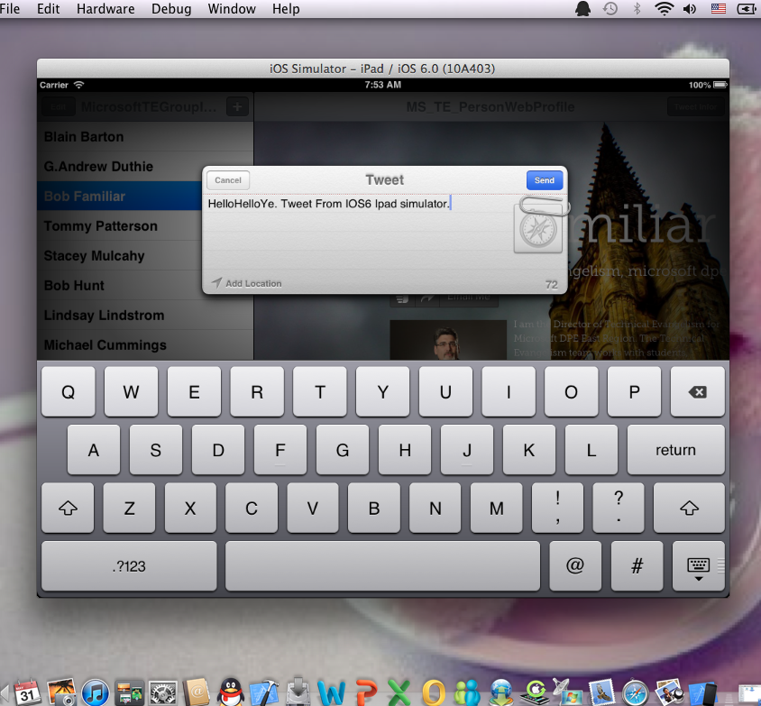

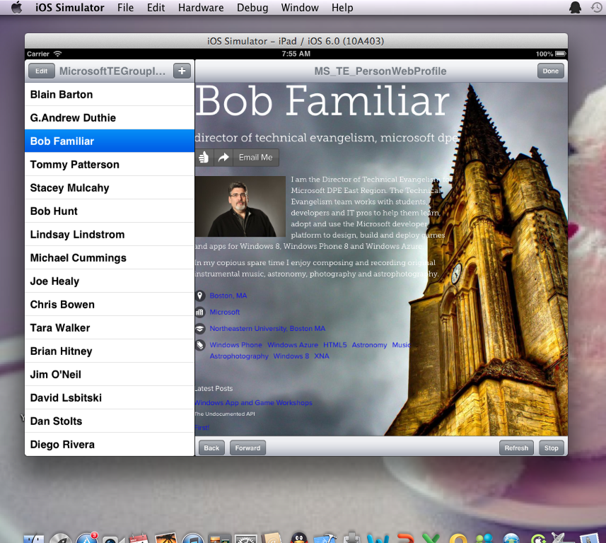



How to integrate the alive data coming from twitter. You can construct a request to do whatever you can do with twitter’s API, interacting nicely with cocoa data type by serilizing Json data. The resource URL for twitter search : <http://search.twitter.com/search.json>

The search term given in argument is q.

Parsing JSON: Cocoa can serialize JSON directly to an NSDictonary; The JSON formate is defined by the Twitter API; So what you get back from executing a TWRequest is an NSData, But you can easily convert it.

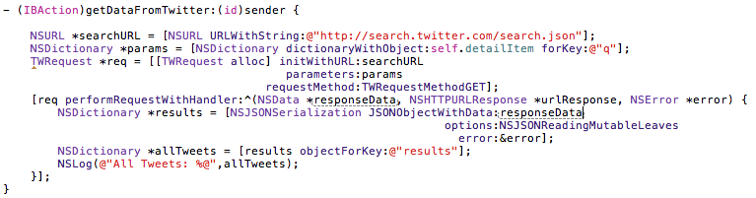

Got Data From Twitter Account:

1: bobfamiliar user account:

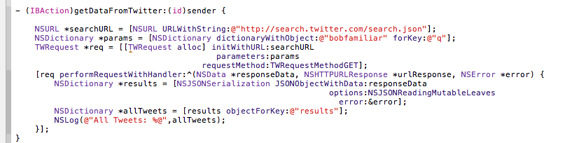

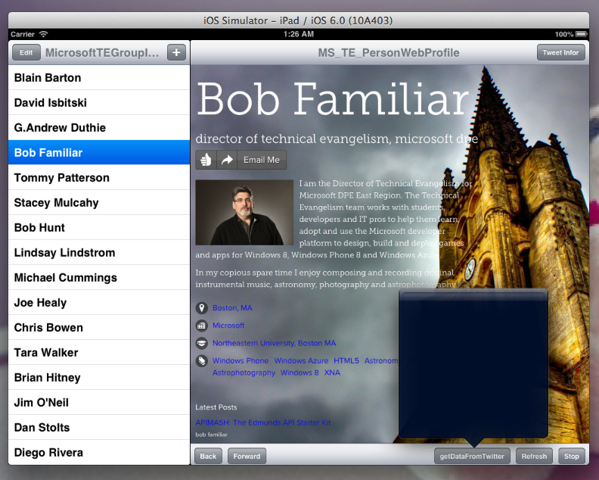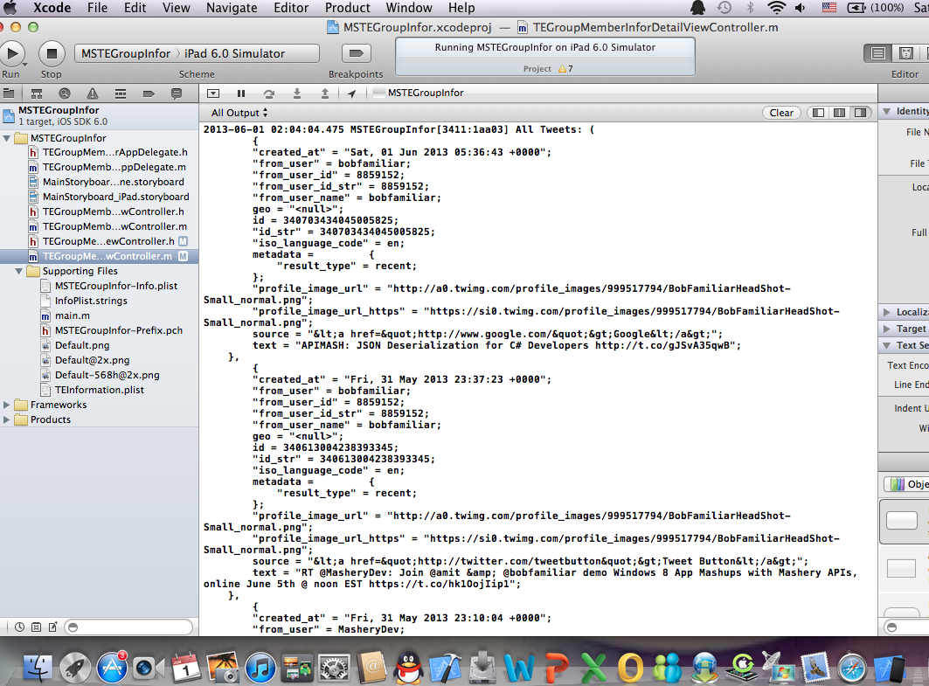

2: JesseFreeman user account

